- First go to https://andy1c1h.github.io/womenplus-ecr-symposium/#submissions to download our latex template.
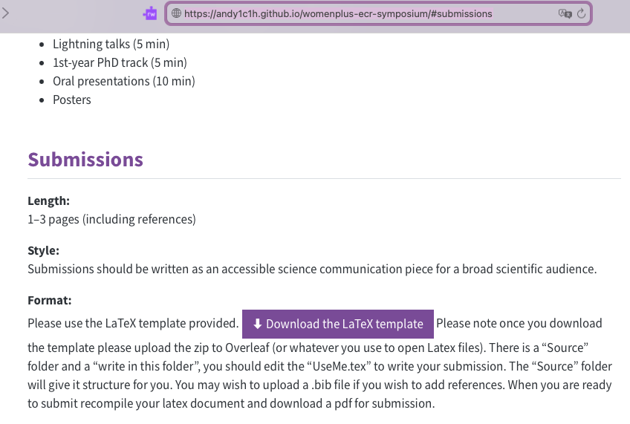

Click this button to download
- Then go to
You may need to create an account but all of the following steps can be done on a free account.
- You should then be brough to this screen
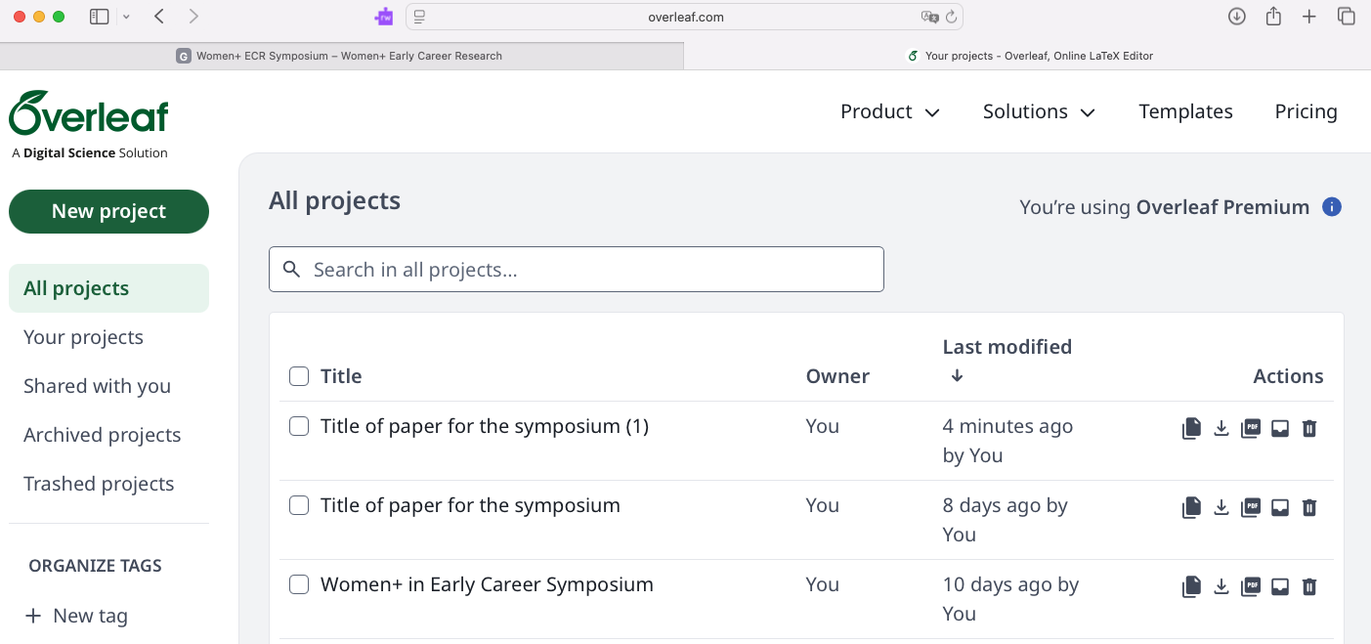
If you have used overleaf before titles will appear here
Click this button to start

- Click Upload project next
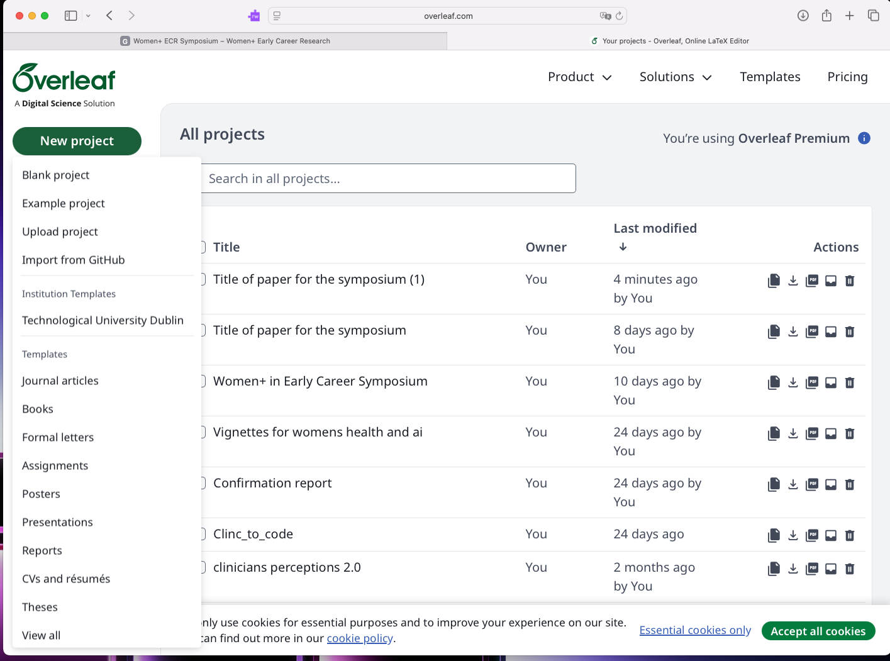
Click this button to upload project

- You will then be asked to upload a file. This will be the file you downloaded in step 1. If the file hasn’t downloaded as a .zip you may need to compress it.

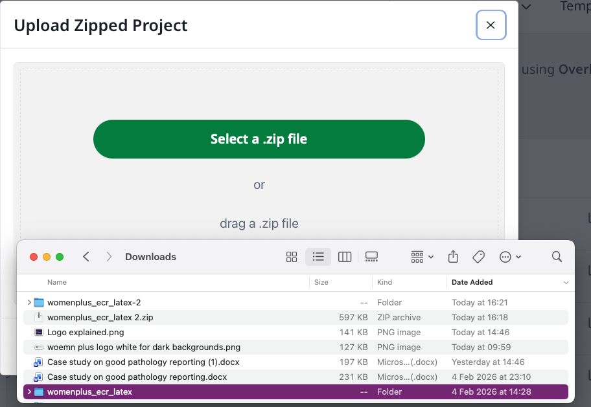

This is the file downloaded

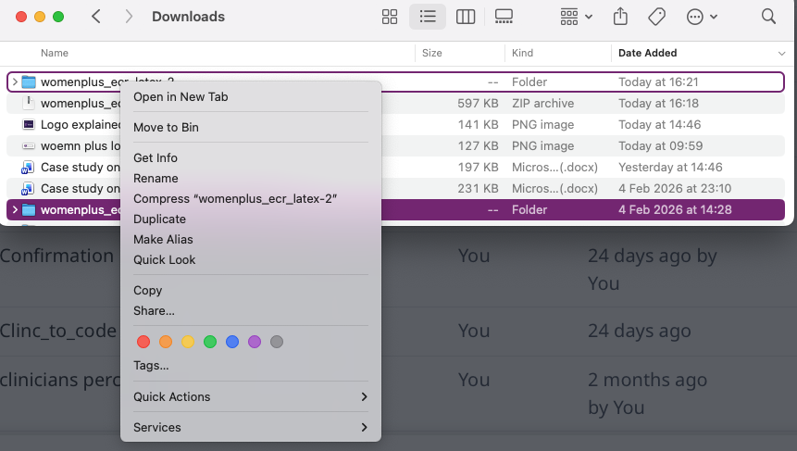
Press compress

- Your file should now .a .zip
- Drag and drop the zip file into this secction

- You should be brought to a page like this.
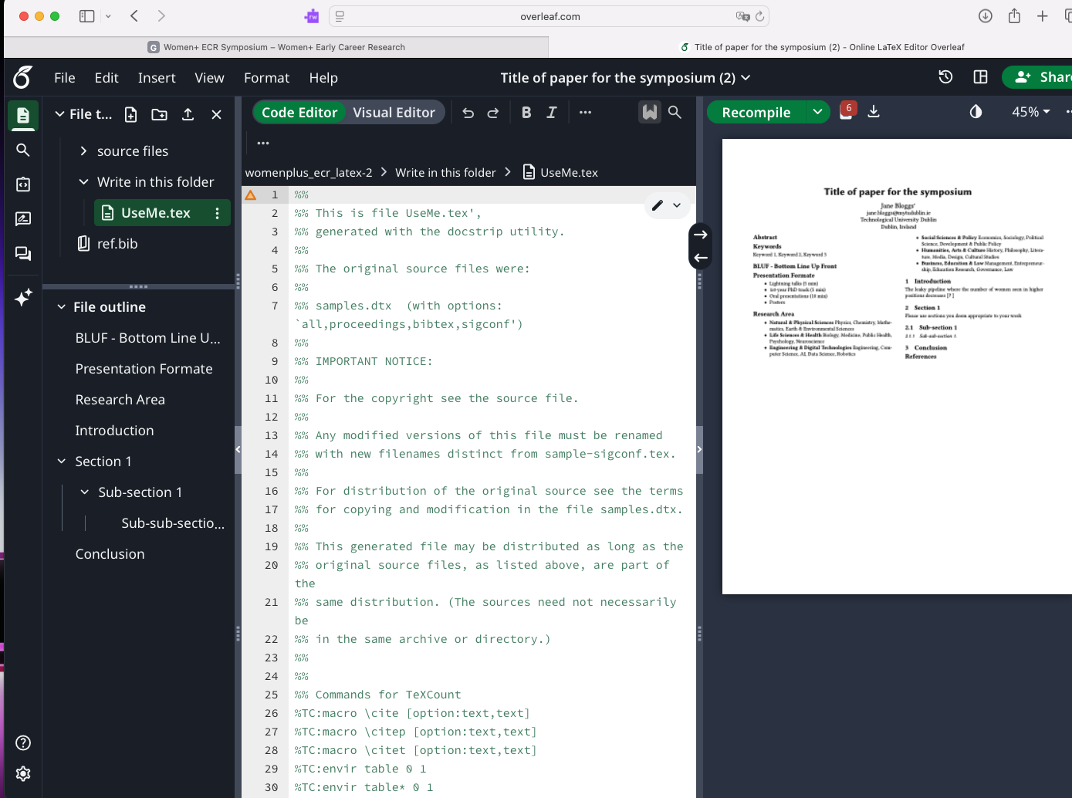
Text in green are context and in typical latex fashion wont be printed on your final paper

This is the file you need to write in

- Scroll down the page You can write in these sections like you would in any latex document.
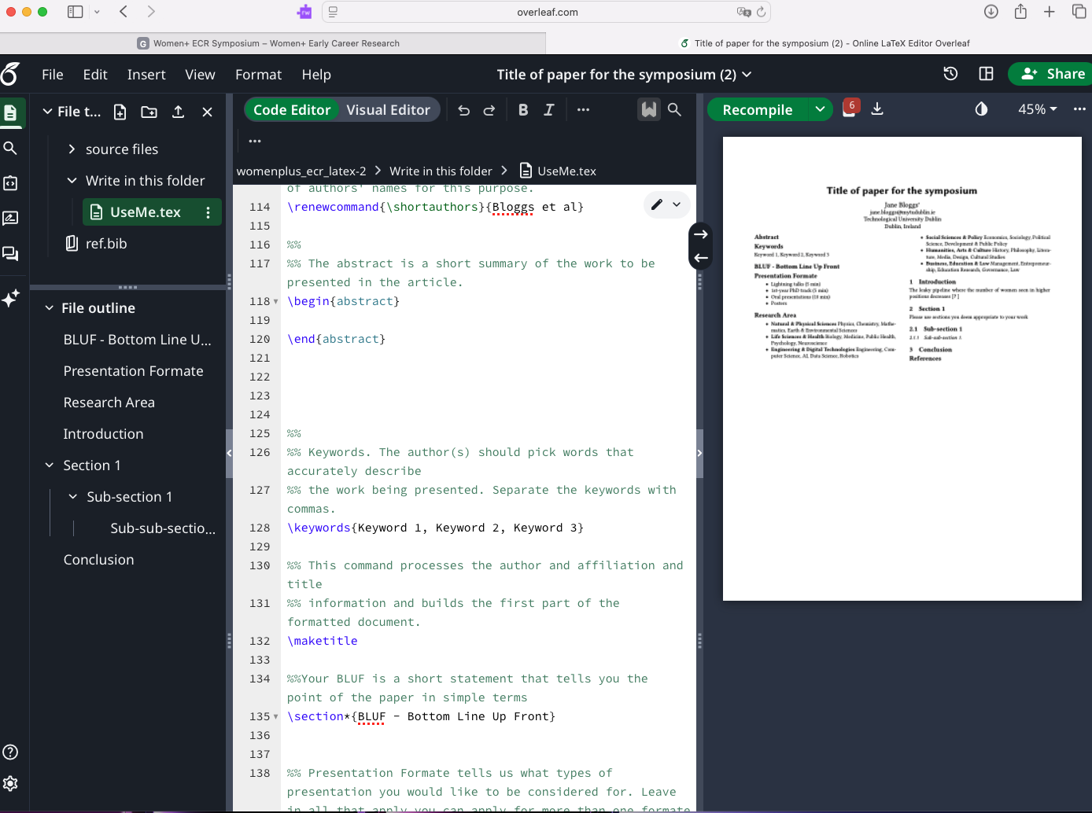
Press the download button to download the finished paper

Your final paper will have a structure like this (we have edited explanations so that if you are having a latex issue you can still work on your submission). Contact andrea.c.heaney@mytudublin.ie if there are any issues using the template so we can work on a solution.